

Green University of Bangladesh

Department of Computer Science and Engineering (CSE)

Faculty of Sciences and Engineering

Semester: (Spring, Year:2021), B.Sc. in CSE (Day/Eve)

Course Title:

Course Code: 209 Section: 193

Lab Project Name: Hospital Management System

Student Details
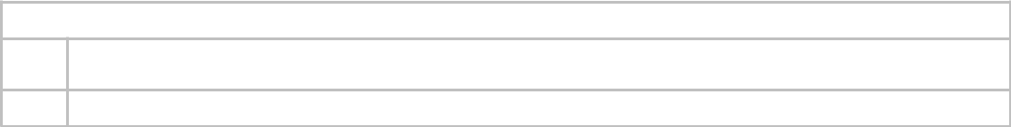

1.

2.

Name | ID
Azmary Akter | 193902019
Jahid Hasan | 193902001

Submission Date : 04.09.2021

Course Teacher’s Name :Md. Moshiur Rahman

[For Teachers use only: Don’t Write Anything inside this box]

 | Lab Project Status
Marks: ………………………………… |  | Signature: .....................
Comments: .............................................. |  | Date: ..............................

Table of Contents

Chapter 1 |  | Introduction | 3
1.1 | Introduction |  | 3
1.2 | Design Goals/Objective |  | 3
Chapter 2 |  | Design/Development/Implementation of the Project | 4
Chapter 3 |  | Performance Evaluation | 5
3.1 | Simulation Environment/ Simulation Procedure |  | 5
3.2 | Results and Discussions |  | 5
Chapter 4 |  | Conclusion | 6
4.1 | Introduction |  | 6
4.2 | Scope of Future Work |  | 6
References |  |  | 7

2 | Page

Chapter 1

Introduction

1.1 Introduction:

The software is for the automotion Hospital management system.

1.2 Design Goals/Objective:

We tried to implement a database where we can put every information and find it very easily.

Goals of proposed system :

1. Planned approach towards working:

The working in the organization will be well planned and organized. The data will be stored properly in data stores, which will help in retrieval of information as well as its storage.

2. Accuracy:

The level of accuracy in the proposed system will be higher. All operations would be done correctly and it ensures that whatever information is coming from the center is accurate.

3. Reliability:

The reliability of the proposed system will be high due to the above stated reasons. The reason for the increased reliability of the system is that now there would be proper storage of information.

4. No Redundancy:

In the proposed system utmost care would be that no information is repeated anywhere, in storage or otherwise. This would assure economic use of storage space and consistency in the data stored.

5. Immediate retrieval of information:

The main objective of the proposed system is to provide for a quick and efficient retrieval of information. Any type of information would be available whenever the user requires.

6. Immediate storage of information:

In a manual system there are many problems with storing the largest amount of information.

7. Easy to Operate:

The system should be easy to operate and should be such that it can be developed within a short period of time and fit in the limited budget of the user.

3 | Page

E-R Diagram of Hospital Management System
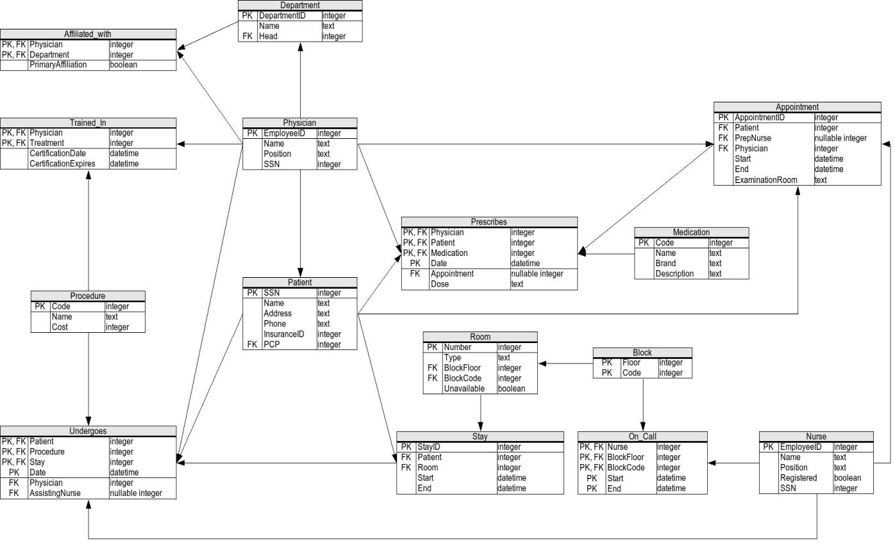

4 | Page

Chapter 2

Design/Development/Implementation of the

Project

The Software includes:- Maintaining Patient details. Providing Prescription, Precautions and health advice.

Providing and maintaining all kinds of tests for a patient. Billing and Report generation.

Implementation Environment

The implementation view of software requirements presents the real world manifestation of processing functions and information structures. This computerized system is specified in a manner that dictates accommodation of certain implementation details.

Database schema of Hospital Management System

A database schema is the skeleton structure that represents the logical view of the entire database. It defines how the data is organized and how the relations among them are associated. It formulates all the constraints that are to be applied on the data. A database schema can be divided broadly into two categories −

- Physical Database Schema:

This schema pertains to the actual storage of data and its form of storage like files, indices, etc. It defines how the data will be stored in a secondary storage.

- Logical Database Schema:

This schema defines all the logical constraints that need to be applied on the data stored. It defines tables, views, and integrity constraints.

List of tables in the hospital database:

- physician

- department

- affiliated_with

- procedure

- trained_in

- patient

- nurse

- appointment

- medication

- prescribes

- block

- room

- on_call

- stay

- undergoes

- user

5 | Page

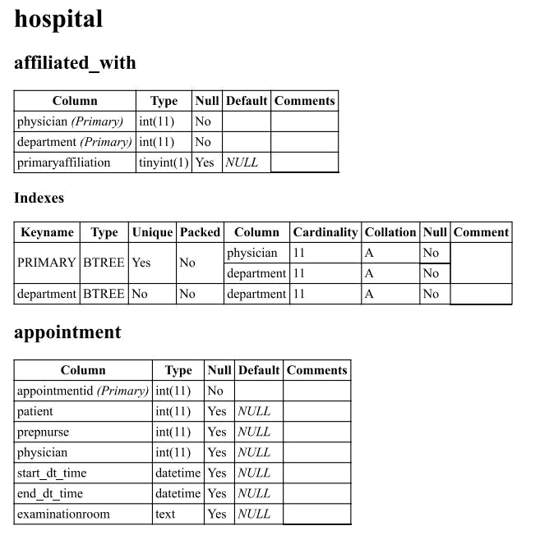

6 | Page
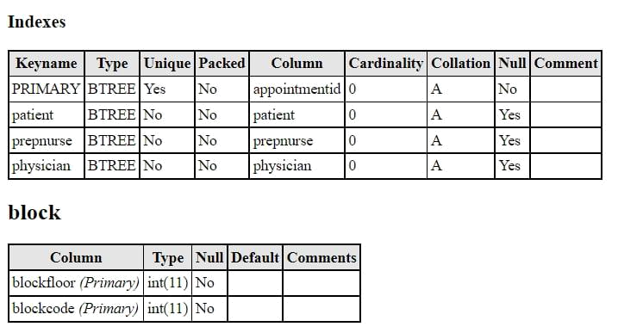

7 | Page
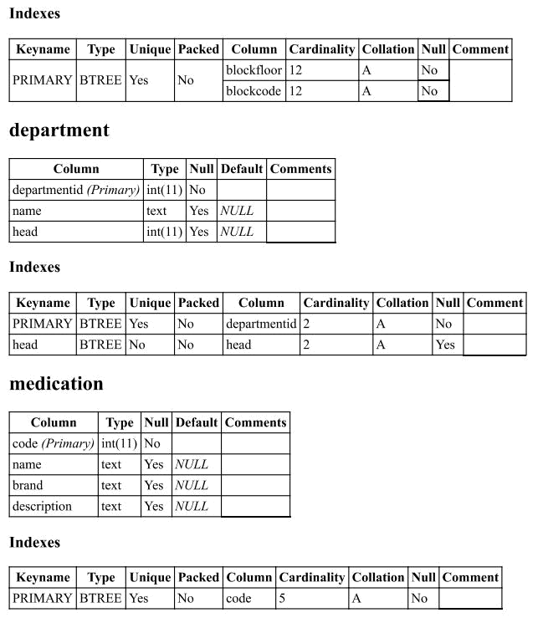

8 | Page
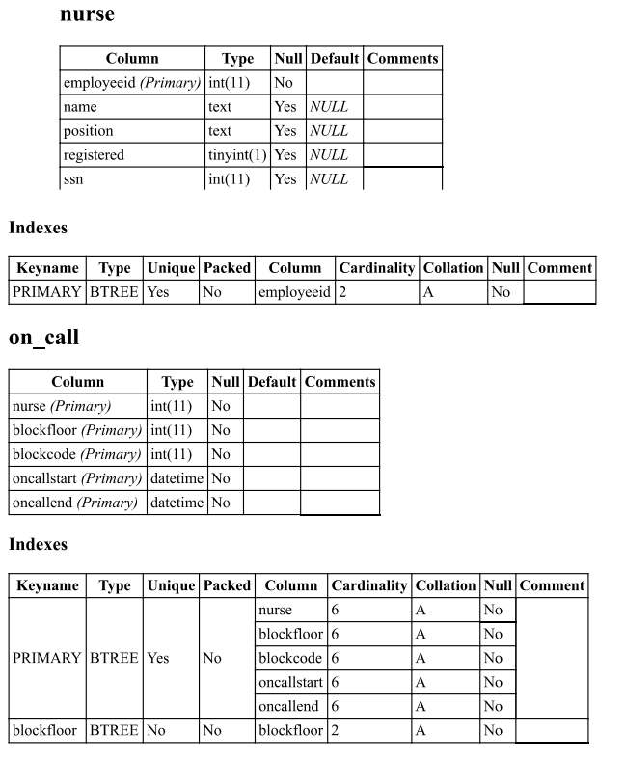

9 | Page
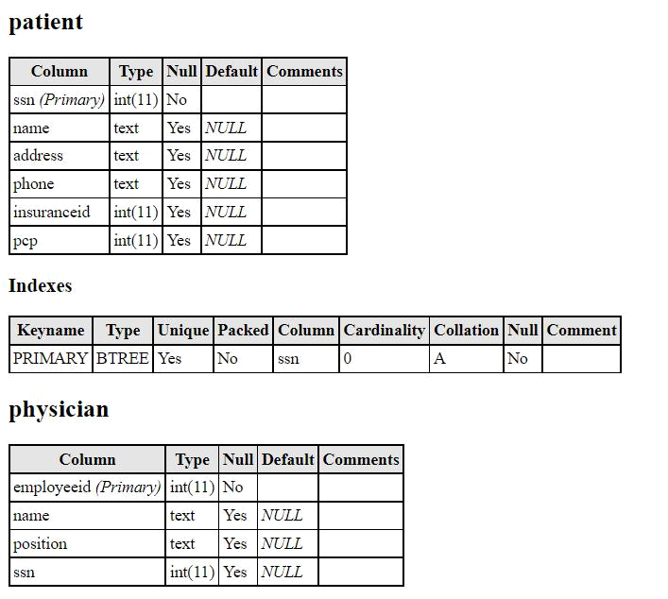

10 | Page
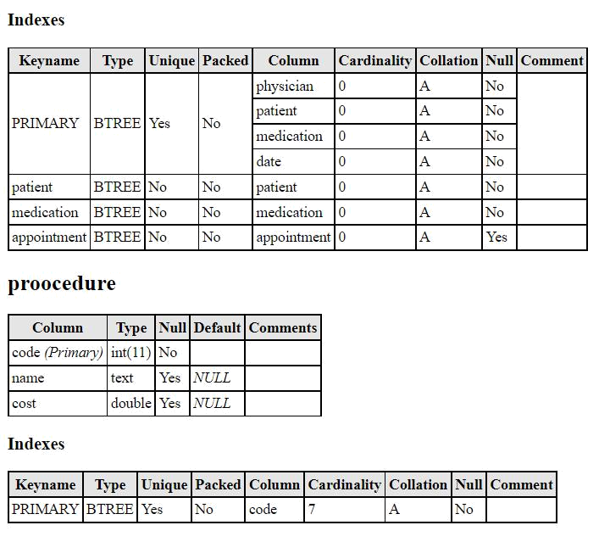

11 | Page
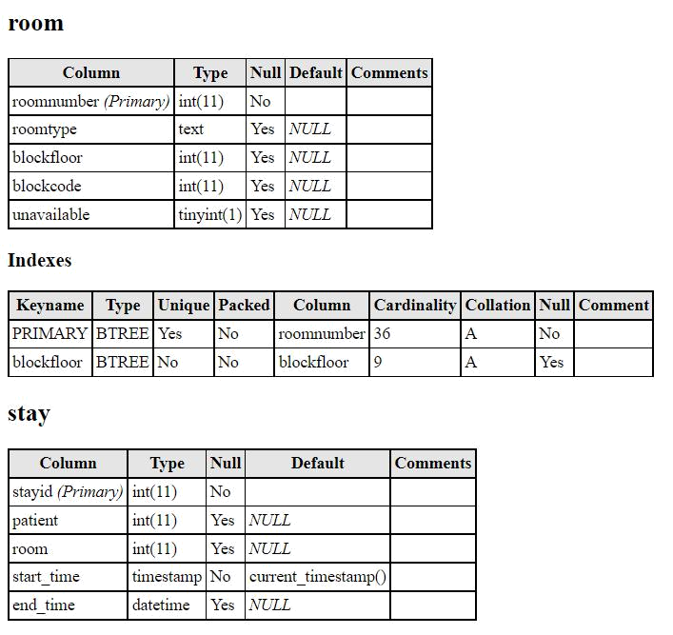

12 | Page
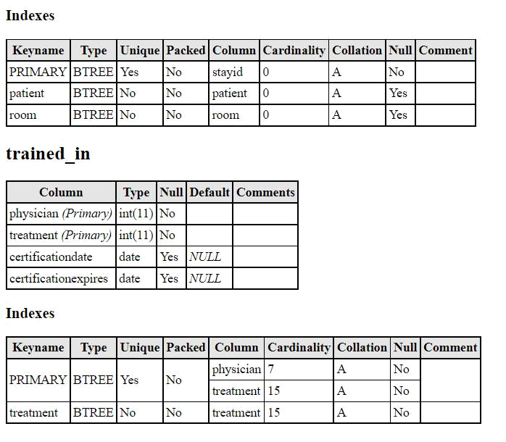

13 | Page
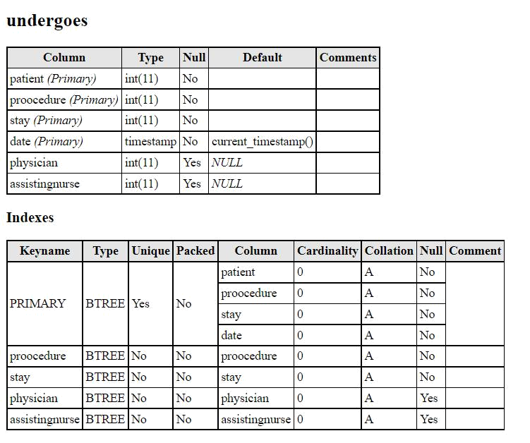

14 | Page
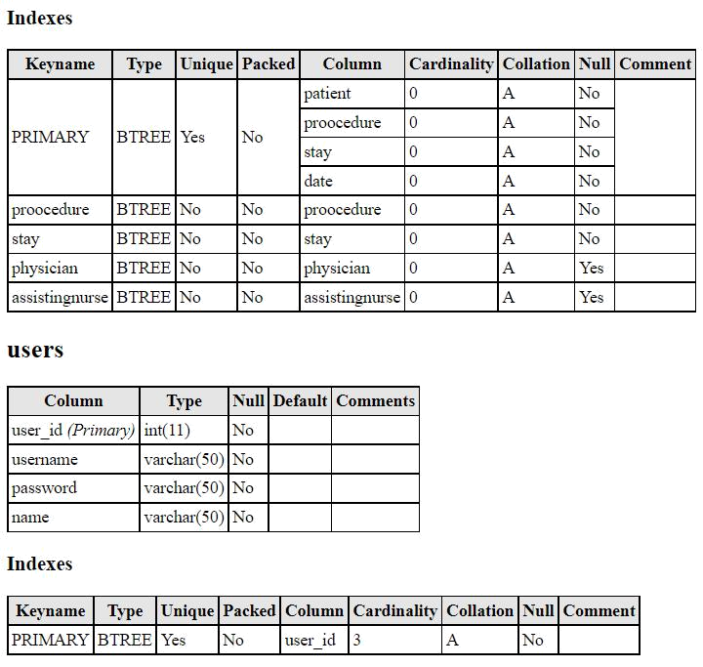

Figure : Hospital management system

15 | Page

User Interface :


16 | Page

Chapter 3

Performance Evaluation
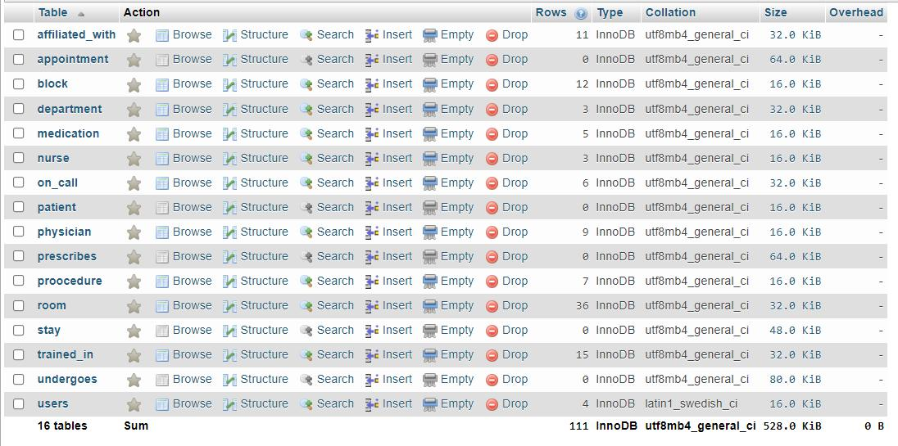

Figure 3.1: Name of figure

3.1 Results and Discussions

3.1.1 Results

Hospital Management System speeds up the working in a hospital. The system takes care of all the requirements of a hospital and provides easy and effective storage of information related to patients that come up to the East London hospital.

3.1.2 Analysis and Outcome

The purpose of the project entitled as “Hospital Management System” is to computerize the Front Office Management of hospitals to develop software which is user friendly, simple, fast, and cost – effective. It deals with the collection of patient’s information like add patient, update patient, delete patient, search patient, view patient diagnosis, etc. Traditionally, it was done manually. The main function of the system is to register and store patient details and doctor details and retrieve these details as and when required, and also to manipulate these details meaningfully.

17 | Page

Chapter 4

Conclusion

4.1 Introduction

This project has been a rewarding experience in more than one way. The entire project work has enlightened us in the following areas.

- We have gained an insight into the working of the HOSPITAL. This represents a typical real world situation.

  - Our understanding of database design has been strengthened this is because in order to generate The final reports of database designing has to be properly followed.

- Scheduling a project and adhering to that schedule creates a strong sense of time management.

- Sense of teamwork has developed and confidence of handling real life project has increased to a to a great extent.

- Initially, there were problem with the validation but with discussions, we were to implement validations.

4.1 Scope of Future Work

- Diagnostics billing system.

References

We take some help from our classmates.

18 | Page

